

**Project Report**

**Smart Challan System**

Submitted by

**Tarun (12090)**

**Parveen (12056)**

**Ankur (12582)**

**Tarun (11095)**

**DRONACHARYA GROUP OF INSTITUTIONS**

#27, Knowledge Park-III, Greater Noida, Uttar Pradesh

**Acknowledgement**

We are very grateful to our project guide Mr. Manoj Kumar Yadav, assistant professor, Dronacharya Group of Institutions Greater Noida, who laid the time bound program for the successful completion of this project. He initiated our thoughts and extended timely suggestions and for his technical support and valuable suggestions for which we are deeply indebted to him. We are grateful to him for his comments and insights in the preparation of this project report without which this report would not have been completed.

We thank sincerely and profusely to all staff members of our Department of our Institute for their valuable help and guidance. We also express our gratitude to the Institute Management to all those who have indirectly help us in the successful completion of this project. Last but not the least, we are deeply indebted to our parents for what we are today, because this project report would not have been a reality without their love and support.

**Table of Contents**

1. Overview

1.1 Title

1.2 Abstract

1.3 Introduction

1.4 Purpose

1.5 Scope

1.6 Hardware used

1.7 Software used

2. Methodology

3. Modelling

4. Objective

5. Project category

6. Fine analysis

6.1 Data flow diagram

7. Program code

8. Functional testing

9. Data modelling

10. Previous solutions

11. Result and discussion

12. Conclusion

13. References

14. Future scope

1. **Overview of project**
   1. **Title of Project**

Smart Challan System

**1.2 Abstract**

Developing countries focus on so many other issues of the country due to which some primary issues are disregarded, one of them is the concern for road safety. Day to day road accidents due to rash driving or over speeding that can be averted are becoming the prime reason for deaths in road accidents. Current solutions to overcome these challenges are either by using speed cameras or using the RFID technology but these technologies have proved inefficient in many ways.

Our solution to the problem is a system installed within the vehicle that would check the speed limit of the zone the vehicle is in with the help of google maps and send a message using GSM, if that speed limit is not maintained. The driver that would be responsible for the indiscipline would pe punished according to the respective law, that in most countries is payment of fine

**Key Words:** GSM, RFID

**1.3 Introduction**

India has been growing rapidly and by growth we do not mean only development. The population of India has continued to increase from the past many years and to order and discipline such a large population becomes quite difficult. Think about our traffic police officers where they need to stand on the road for the complete day to avoid chaos on road. It becomes difficult for them to fine the culprits, and the indiscipline on the roads carry on, so to avoid such problems, we have come up with the solution, where the system would be embedded in the vehicle that would help the authorities to maintain discipline on the roads by monitoring the speed of the vehicles and even helping them to fine the culprits.

The paper consists of following sections:

“Methodology” which explains the method used to make donation app.

“Modelling” which explains the structure of the models present in the project.

“Result” that shows the experimental analysis of the model.

“Conclusion” that shows the results and conclusion.

* 1. **Purpose**

The purpose of this project is to help curb the indiscipline and chaos on roads to whatever extent it can. This project would work as a helping hand for the traffic police in curbing the indiscipline and would even help in finding the culprits, the project would reduce the amount work of traffic police and would prove to be an efficient help.

**1.5 Scope**

The project can be implemented in any car and the manufacturers would be the sole authority to install this project in their vehicles and after getting the permission from the concerned governments it can be used for the safety of people.

* 1. **Hardware Used**

This project is a hardware-based project and the components used in this project are:

• Arduino Uno:

*A microcontroller board, Arduino Uno is based on ATmega328P. It has 14 input/output pins out of which 6 can be used as PWM outputs, 6 analog inputs. It also has a 16 MHz quartz crystal, a USB connection, a power jack, an ICSP header and a reset button.*

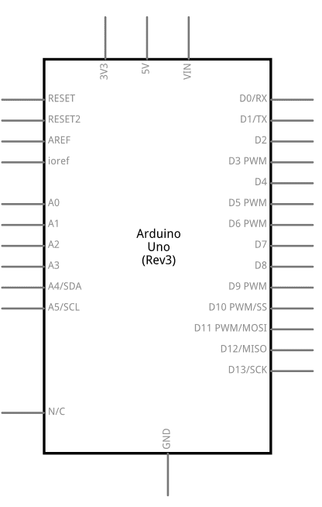

• GSM:

*An open and digital cellular technology, GSM is utilized for transporting voice over cellular and data related services which operate at the frequencies of 850MHz, 900MHz, 1800MHz, and 1900MHz bands. This technology was developed as a digital system using the time division multiple access (TDMA) technique for communication purposes.*

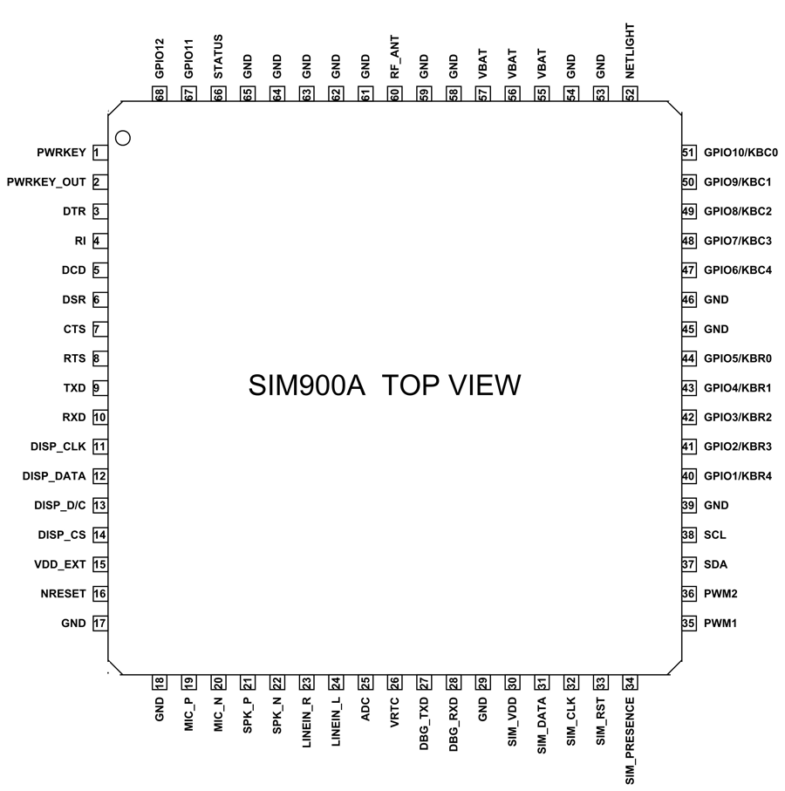

• IR sensor:

*The IR sensor module consists mainly of the IR Transmitter and Receiver, Op amp, Variable Resistor (Trimmer pot), output LED in brief. IR LED Transmitter. IR LED emits light, in the range of Infrared frequency. IR light is invisible to us as its wavelength (700nm – 1mm) is much higher than the visible light range*

• Buzzer:

*The buzzer would be used to alert the driver for his/her wrongdoing.*

• Connecting Wires

* 1. **Software Used**

The software used in the project is Arduino uno coding environment where we have coded for the defined purpose, the language used is embedded C.

1. **Methodology**

The project would firstly gather the real time location of the vehicle and then would collect the speed limit of that location, after this the system would gather the vehicle’s current speed and would then compare the speed limit of the location and the current speed of the vehicle, if the current speed of the vehicle is greater than the pre-defined speed limit of the location then the buzzer would be triggered to notify the user about hi wrong doing and if the driver keeps on with this trend then, the vehicle details would be forwarded to the concerned authority and the driver would have to face the repercussions.

1. **Modelling**

Project flow diagram:

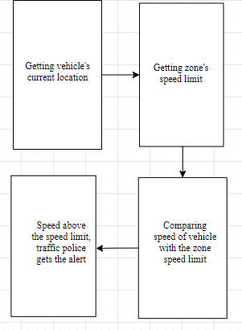

1. **Objective**

The objective of this project is to prevent indiscipline on the roads and try to prevent as many road accidents as possible. The project would completely be implemented only after the concerned government permission and would not be used for any foul means by anyone.

1. **Project Category**

Hardware-based project

1. **Fine Analysis**

The fine which would be the prime repercussion on breaking the rule can done by any of the two ways:

• By being physically present at the court

• By virtually or online payment

The virtual or the online payment method is more convenient and it would also be time efficient. This method is commonly termed as E-challan

* 1. **Data Flow Diagram (DFD) for E-challan**

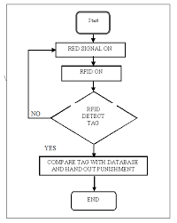

1. **Program code**

#include <SoftwareSerial.h>

#define LIMIT1 1000 // Change it accordingly.

#define LIMIT2 2000

#define buzzer 7

#define sensor 8

SoftwareSerial mSerial(10, 9);//Connect 9 to TX of GSM and 10 to RX of GSM

int delay1()

{

//unsigned int long k;

int i, j;

unsigned int count=0;

for(i=0; i<1000; i++)

{

for(j=0;j<1000;j++)

{

if(digitalRead(sensor))

{

count++;

while(digitalRead(sensor));

}

}

}

return count;

}

void setup()

{

pinMode(sensor, INPUT_PULLUP);

pinMode(buzzer, OUTPUT);

Serial.begin(9600);

mSerial.begin(900); // Setting the baud rate of GSM Module

}

void loop()

{

unsigned int time=0,RPM=0;

time=delay1();

RPM=(time*12)/3;

delay(2000);

Serial.print("RPM=");

Serial.println(RPM);

delay(500);

if(RPM>=500&&RPM<=1000)

{

digitalWrite(buzzer,HIGH);

Serial.println("Limit 1 crossed");

SendMessage1();

delay(2000);

digitalWrite(buzzer,LOW);

}

if (RPM>=1000)

{

digitalWrite(buzzer,HIGH);

Serial.println("Limit 2 crossed");

SendMessage2();

delay(2000);

digitalWrite(buzzer,LOW);

}

}

void SendMessage1()

{

//digitalWrite(BUZZ, LOW);

mSerial.println("AT");

delay(500);

//erialPrint(); s

mSerial.println("AT+CMGF=1");

delay(500);

// serialPrint();

mSerial.print("AT+CMGS=");

mSerial.print('"');

mSerial.print("+918076341864"); //mobile no. for SMS alert

mSerial.println('"');

delay(500);

mSerial.print("Vehicle number 123456789 has crossed the speed limit.At JANAK PURI red light");

delay(500);

mSerial.write(26);

delay(2000);

}

void SendMessage2()

{

//digitalWrite(BUZZ, LOW);

mSerial.println("AT");

delay(500);

//erialPrint(); s

mSerial.println("AT+CMGF=1");

delay(500);

// serialPrint();

mSerial.print("AT+CMGS=");

mSerial.print('"'); mSerial.print("+918076341864"); //mobile no.for SMS alert

mSerial.println('"');

delay(500);

mSerial.print("Vehicle number 987654321 has crossed the speed limit.At PUNJABI BAGH red light");

// mSerial.print(sensorValue);

delay(500);

mSerial.write(26);

delay(2000);

}

1. **FUNCTIONAL TESTING**

Functional testing is a formal type of testing performed by testers. Functional testing focuses on testing software against design document, Use cases and requirements document. Functional testing is a black box type of testing and does not require internal working of the software unlike white box testing.

1. **DATA MODELLING**

Data modelling defines primary data objects, composition of each data object, and attributes of the object, relationships between each object and other objects and between objects and the process.

1. **Previous Solutions**

There exist two solutions currently, one, using the speed camera, that captures the number plate of the vehicle, which are quite costly, second, the one using the RFID technology where each car is equipped with a fast tag that makes it easier for the camera to scan, but both these solutions shows inefficiency when multiple vehicles cross at the same time, moreover, every nook and corner cannot have a camera and a scanner, this acts as a loop hole for these solutions.

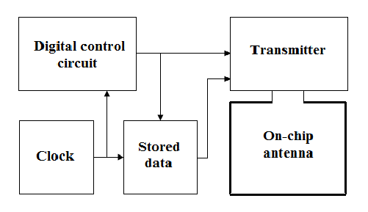

1. **Result and discussion**

The project was successfully designed and tested. The project works as helping hand for the law protectors, for law protectors cannot be present everywhere, so our project sends the message with the help of GSM and then the traffic police can fine the vehicle for breaking the law.

The result will be displayed as:

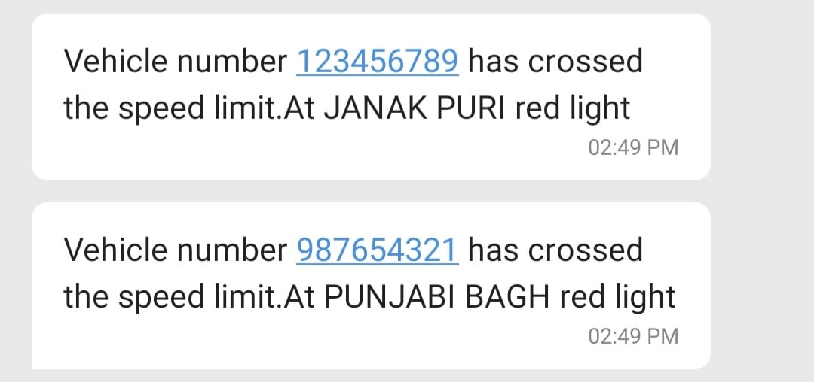

1. **Conclusion**

In this paper our proposed idea is to control chaos and indiscipline on roads and providing the law breaker with an automated challan that would save time his/her time and makes it easy for the traffic police to fine the culprits.

We also hope that the project proves useful and helps the law protectors in maintaining discipline and avoiding accidents on roads.

1. **Références**

• International Research Journal of Engineering and Technology [IRJET] e-ISSN: 2395-0056; p-ISSN: 2395-0072; Volume: 07 Issue: 03|Mar 2020 available at [www.irjet.net](http://www.irjet.net)

•https://www.google.com/search?q=ir+sensor+module&oq=Ir+se&aqs=chrome.1.69i57j69i59l2j0l7.1827j0j7&sourceid=chrome&ie=UTF-8

• International Journal of Computer Applications ISSN: 0975-8887; Volume: 176 -No.37 Issue: July 2020

• International Journal of Advanced Engineering and Research Development [IJAERD] e-ISSN: 2348-4470; p-ISSN: 2348-6406; Volume: 4 Issue: 08|Aug 2017 available at www.ijaerd.com

• International Journal of Electronics, Communication & Instrumentation Engineering Research and Development (IJECIERD) ISSN: 2249-684X Vol.2 Issue: 03|Sept 2012

•https://www.google.com/search?q=rfid+tag+working+block+diagram&sxsrf=ALeKk024TCzZ8CwhdiBFg1bu_3V_F-4oVQ:1624628357793&tbm=isch&source=iu&ictx=1&fir=8gdOGi9hzX

**Are you doing the project for industry or organization?**

NO, we are not doing this project for any industry or any organization. This project is developed for Academic purpose. It was developed at college campus for the fulfilment of Project under supervision of our faculty.

Our team consist of 4 members (Tarun, Parveen, Ankur & Tarun Kumar).

**14. Future scope and further enhancement**

This project can be used for the real world and would prove very efficient in many as compared to the current exiting solutions to the defined problem